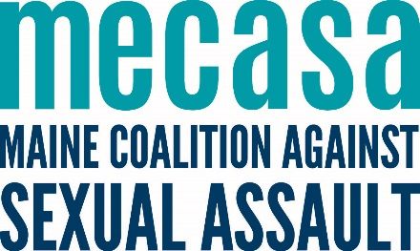

Public Policy and Campus Sexual Assault Fellowships
at Maine Coalition Against Sexual Assault

ABOUT MECASA:

The Maine Coalition Against Sexual Assault is organized to end sexual violence and to support high quality sexual violence prevention and response within Maine communities.

For over 40 years, MECASA has represented and served Maine’s sexual assault support centers. MECASA works toward ending sexual violence through:
- Coordinating training and peer sharing opportunities,
- Developing resources,
- Providing one-to-one support and advice to sexual assault support centers and other partners in the anti-sexual violence movement,
- Funding victim services and prevention efforts in Maine’s communities, and
- Advocating for victim-centered public policy and systems change.
MECASA engages in programming and partnerships to bring the voices of Maine’s sexual assault support centers and the victims/survivors they serve to inform statewide and national sexual violence prevention and response.

ABOUT THE FELLOWSHIPS:

The fellows’ work will focus on research and training projects related to the criminal justice system and other systems, such as Title IX processes in schools and other court access issues. Specifically, the public policy fellows will work on two long-term research projects involving an in-depth national review of laws, policies, best practices, case law, and procedures in specific policy areas impacting sexual violence survivors. Additionally, there is the opportunity to research, compile, and develop resources and recommendations to best support campus sexual assault prevention and response efforts across the state.

Two fellowship placements are available. According to interest, one position will weigh more heavily toward policy research and review and will be offered during the summer of 2024. The other role will weigh more heavily toward research and development of prevention and response strategies for support campus staff and will be offered (with a possible earlier start) during the summer of 2024. The fellows’ work can be fully remote, but there will be an option to attend some in person events, trainings, and observations if the fellows are interested.

Compensation of up to $5,000 for the summer fellowship and up to $7,500 for the spring/summer fellowship may be available based on level of financial support available from the fellow’s institutions of higher learning.

QUALIFICATIONS:

- Awareness of and sensitivity to issues of sexual victimization
- Strong research and writing skills
- Experience and/or interest in a related field, including criminal justice, sexual assault advocacy, legal services, or Title IX, either professional or lived experience
- Experience working independently, while knowing when to engage team members
- Commitment to intentionally seeking, receiving, and integrating the input of others
- Ideal candidates could be a law, public policy, or public health post-graduate student or an undergraduate student with related courses, work, or lived experience in these areas

Maine Coalition Against Sexual Assault is committed to creating an inclusive environment for staff and volunteers. We encourage applications from people with diverse backgrounds, including women, Black, indigenous, and people of color, people who identify as LGBTQIA+, people with disabilities, immigrants, and people who have experienced poverty or homelessness.

HOW TO APPLY:

Applications are due March 20, 2024. Applicants should submit a cover letter and resume addressed to Melissa Martin, Esq. (she/her), Public Policy and Legal Director, at martin@mecasa.org and Lisa Rävar (she/her), Prevention Director, at lisa@mecasa.org. Applicants should include in their cover letter 1) why they are interested in the fellowship, and 2) their qualifications for the fellowship.

